**File Sharing**

**Download and installation.**

* Open a browser and go to the url <https://sysprogs.com/SmarTTY/>. Download the SmarTTY application. This is an SSH Client with SCP file sharing.

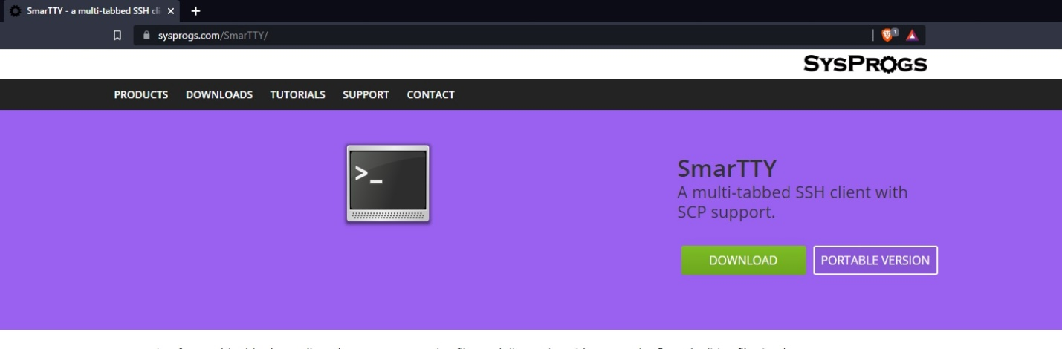

* Once downloaded, run SmarTTY and login to the linux server. To log in to the linux server, use the ip address of the server as the host name, and the login with the user credentials you created earlier.

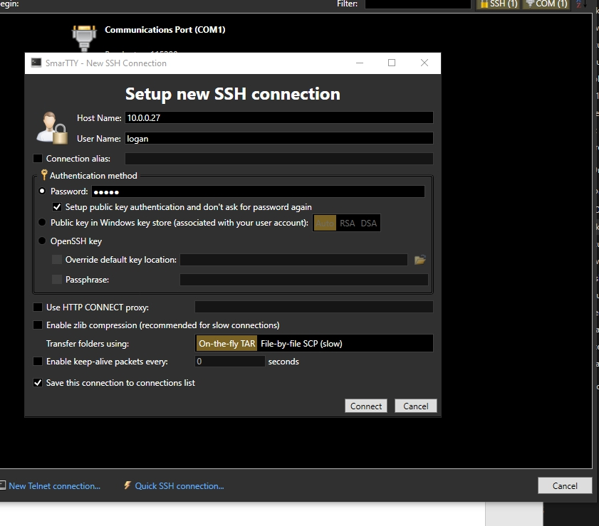

* To test the file transfer, click SCP and from the drop-down menu select upload a file. Then upload a file of your choice to the tmp directory. You can see the upload is successful if there is a green check mark next to it on the tab below.

